# File permissions in Linux

## Project description

As a cybersecurity analyst, I’ll be examining the existing permissions of the file and directories in the /home/researcher2/projects directory. I’ll be revising and ensuring the appropriate permissions are set for the intended groups and individuals. This will keep security permissions updated and ensure nobody has access to files or directories that they shouldn’t. This is practicing the Least Privilege principle.

## Check file and directory details

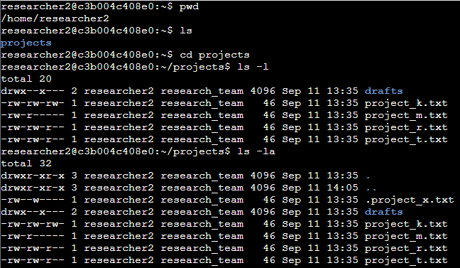

## Describe the permissions string

An example from the above screenshot: **project_k.txt**

The file permissions string initially is -rw-rw-rw-.   
  
The permissions string is a 10 character string indicating the file type, then permissions for the user, the group, and others.  
  
In this example the first character is -, indicating this is a file and not a directory.

The next 3 characters indicate the permissions for the user. Currently rw-, means the user has permissions to read and write, but not to execute.  
  
The next 3 characters (4-7) indicate permissions for the group. Currently rw-, Which means the group has permissions to read and write, but not to execute.

The final 3 characters (8-10) indicated permissions for all other groups, or others. Currently rw-, others also have permission to read and write, but not execute.

## Change file permissions

The only file left where others have write permissions is project_k.txt. The organization does not allow any others to have write permissions in this directory. To change this, we can use the **chmod o-w project_k.txt** to remove the write permission.  
  
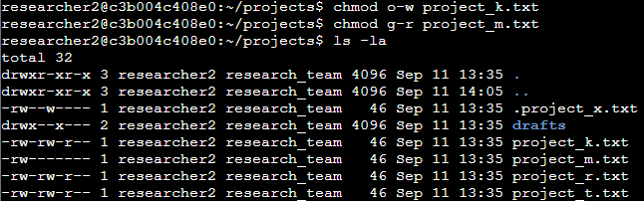

## Change file permissions on a hidden file

The hidden file .project_x.txt should not have write permissions for any one, but the user and group should be able to read it. To change this, I used the command **chmod u=r,g=r .project_x.txt.**

The = replaces all permissions with the ones listed. Since we only want the user and group to have read permission, we set it exactly to read only, which will automatically take away the other permissions (write).

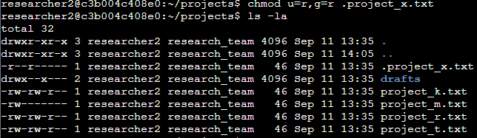

## Change directory permissions

We want to take away the write permission from the group for the drafts directory. For this we can also use the chmod command. I used **chmod g-x drafts**.

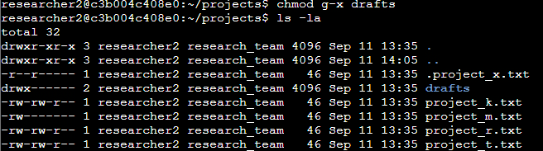

## Summary

We were able to navigate the /home/researcher2/projects directory to change permissions for files, hidden files, and directories within /projects. This is a real scenario where permissions may need to change due to certain groups no longer needing access to these files, or new groups needing to now edit these files. This is important for safe-keeping and allowing minimizing the attack surface if certain groups no longer need access to these files/directories. This practices the Least Privilege principle.